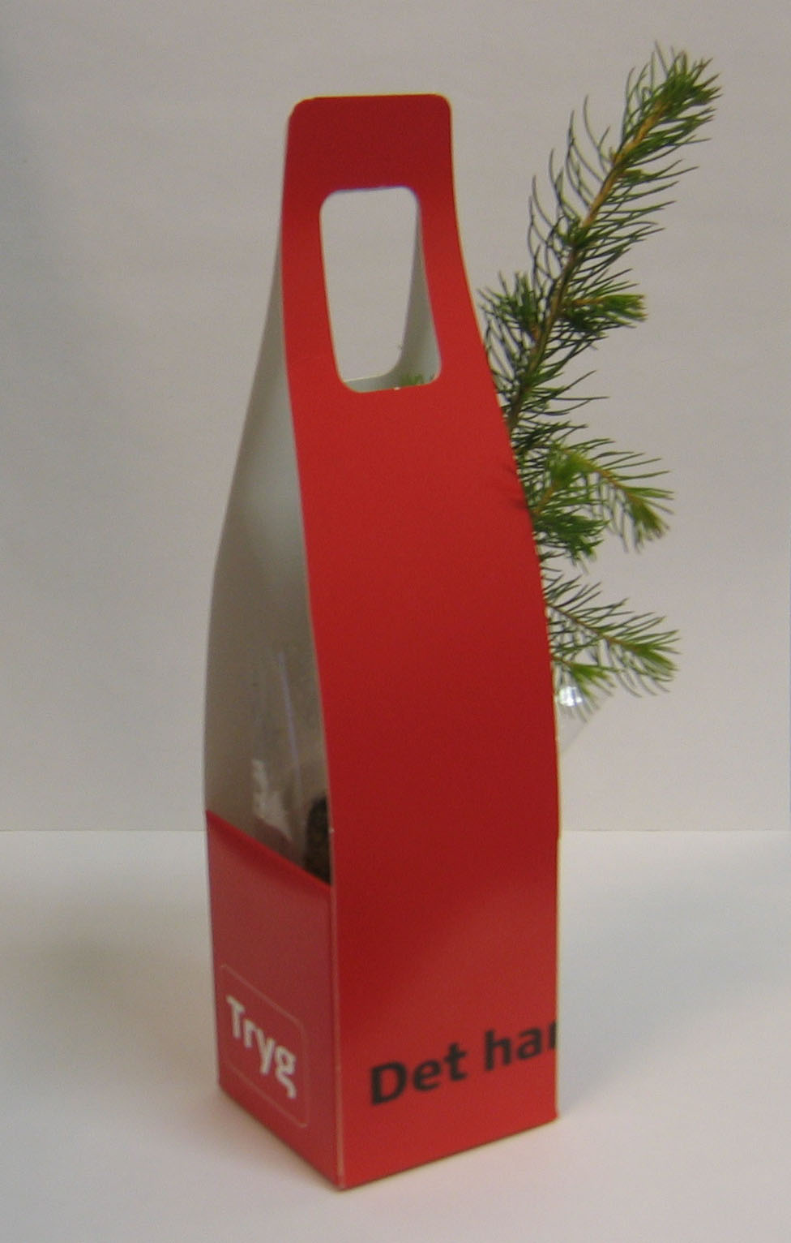
CASE 2 promo seeds scandinavia

January 2005

Product: Handy box with tree
Quantity 7.500 pcs.

Customer: Tryg Forsikring – DK
The No. 2 largest insurance company in Northern-Europe, with 2.000.000 Clients and 2.300 employees.

Event: They wanted a give away for an big Agriculture-Exhibition in Denmark. Each visitors and clients was given one.

Story: The name of the Insurance Company is “Tryg” that means “Safe” in english. They have a lot of TV-spots with Stories that tell that there clients shall be safe. Therefore they ment that our idea with trees to safe the forest was very good.
At the time we did not know that the big hurricane will arrive just a week before the exhibition.
The timing was very well and more than 7.000 peoples walking around on the exhibition with our
Handy-tree-boxes.

Result: We got a phonecall from the head office to tell us about the success. The client is now informed
that we can make special promotions and events.

Productdata: Carton box printed in 2 colours + varnish, size 65 x 65 x 260 mm.
Cutting out, glued and assemble, delivered with trees in each box in special sending packaging, on pallets.
The boxes contents: one pine tree.

Sales price: about Euro 2,40, delivered.



