Case Mercedes-Benz
Prod u ct:
Custom er:
Event:
Result:
Productdata:
February 2006

Seedpack with Sunflower seeds
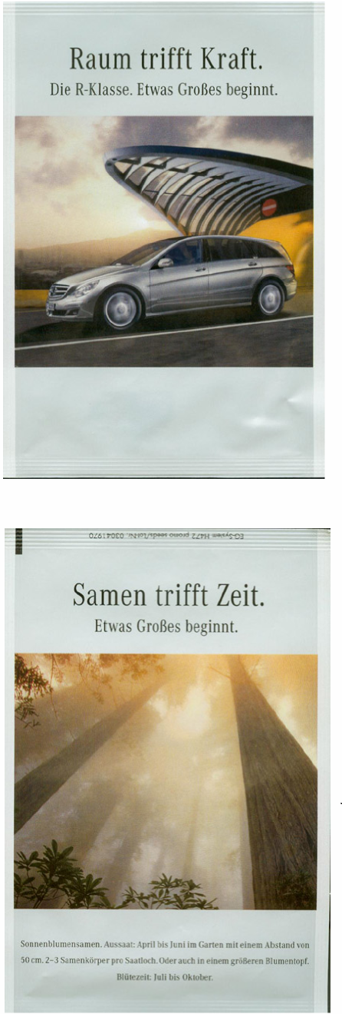
Qu antity:
157.000 for Germany
6.000 for Austria
Mercedes-Benz
The order was given by the advertising agency
Mercedes just launched a new car which is called “R-Klasse”. Every new sold car will be equipped with infomaterial and a seedpack. For the design of the seedpack they chose the picture from the campaign you can see on TV and in magazines right now. The advertising message on the front of the seedpack is: “space meets power” and the message on the back says: “seed meets time”
We have no results at the moment except that the customer was very pleased with the product.
Seedpack, paper/PE,
size 101,6 x 150mm
Design made by the client

