

GREEN INNOVATION

Sommer 2005

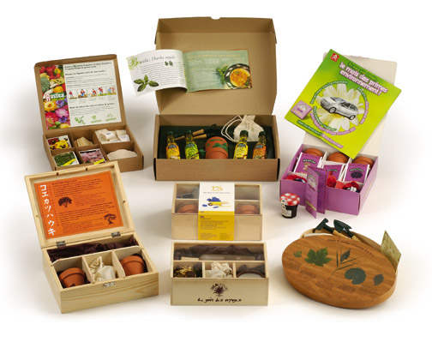



promo seeds Sverige
08-708 00 80 info@promoseeds.se

