

GREEN INNOVATION

Sommer 2005

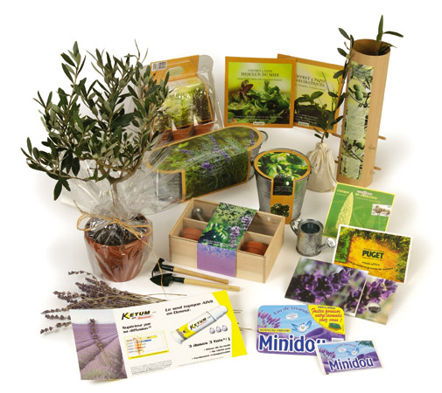


promo seeds Sverige
www.promoseeds.se info@promoseeds.se

