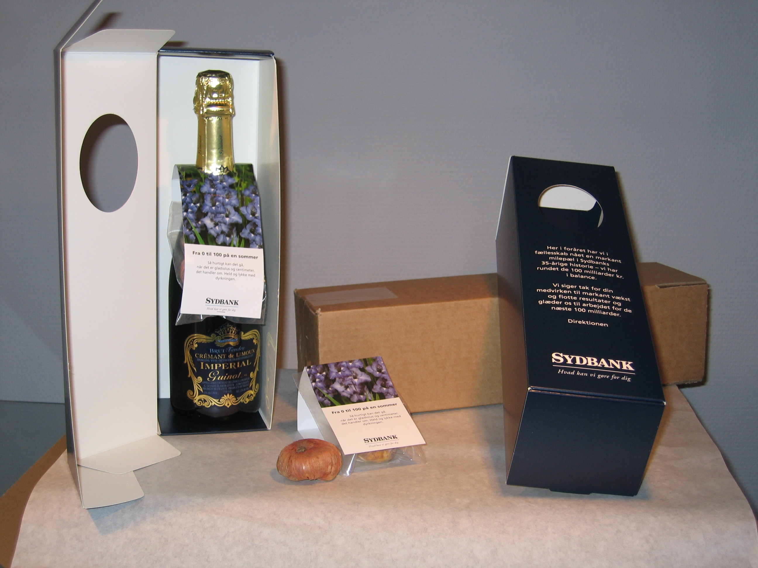
CASE 28. 04. 2006

Product: Gladiolus Blue Isle Bulb
Packed in plastic bottle hanger
On champagne bottle,
Delivered in gift box.
Delivered quantity 2.542 pcs.

Customer: Sydbank – DK
4th largest bank in Denmark
With around 130 branch offices (+ 1 in Germany and 1 in Switzerland)
There are 2.500 employees.
Balance as per 25th April
DKK 100.000.0000.000

Objective: To emphasize the great quarterly result towards all employees.
As the result was not made public in advance the gift should be a surprise for all employees and arrive at the same time in all branch offices.

Story: The bank enquires about a delivery of gladiolus bulbs in blue colour. When going through the total idea we offer to solve the full project: Gladiolus bulbs packed in a plastic bag bottle hangers, printed in 4 colours on front and cut in special format. Packed in specially made champagne boxes printed in one colour. The Gift box was packed in an inner box which again was packed in an outer carton box containing 6 inner boxes.
The delivery to all branch offices was made at the exact same time by special delivery all over the country.

Result: A small flower bulb resulted in an exciting order for a full concept.
We have got a good order, a happy and satisfied customer and a very good reference.

Product data: Gladiolus Blue Isle Bulb, a flower which matches the colour image of the bank.
To be planted in the spring and flowers in July/September. The height of the plant is 90-100 cm.
The champagne was especially imported from Alsace for this purpose.
The inner and outer box was also especially produced for the occasion.
Approximate price per pc is EUR 14.75.

LAST MINUTE ORDER

The full project from finish to end was delivered in 2 weeks.



