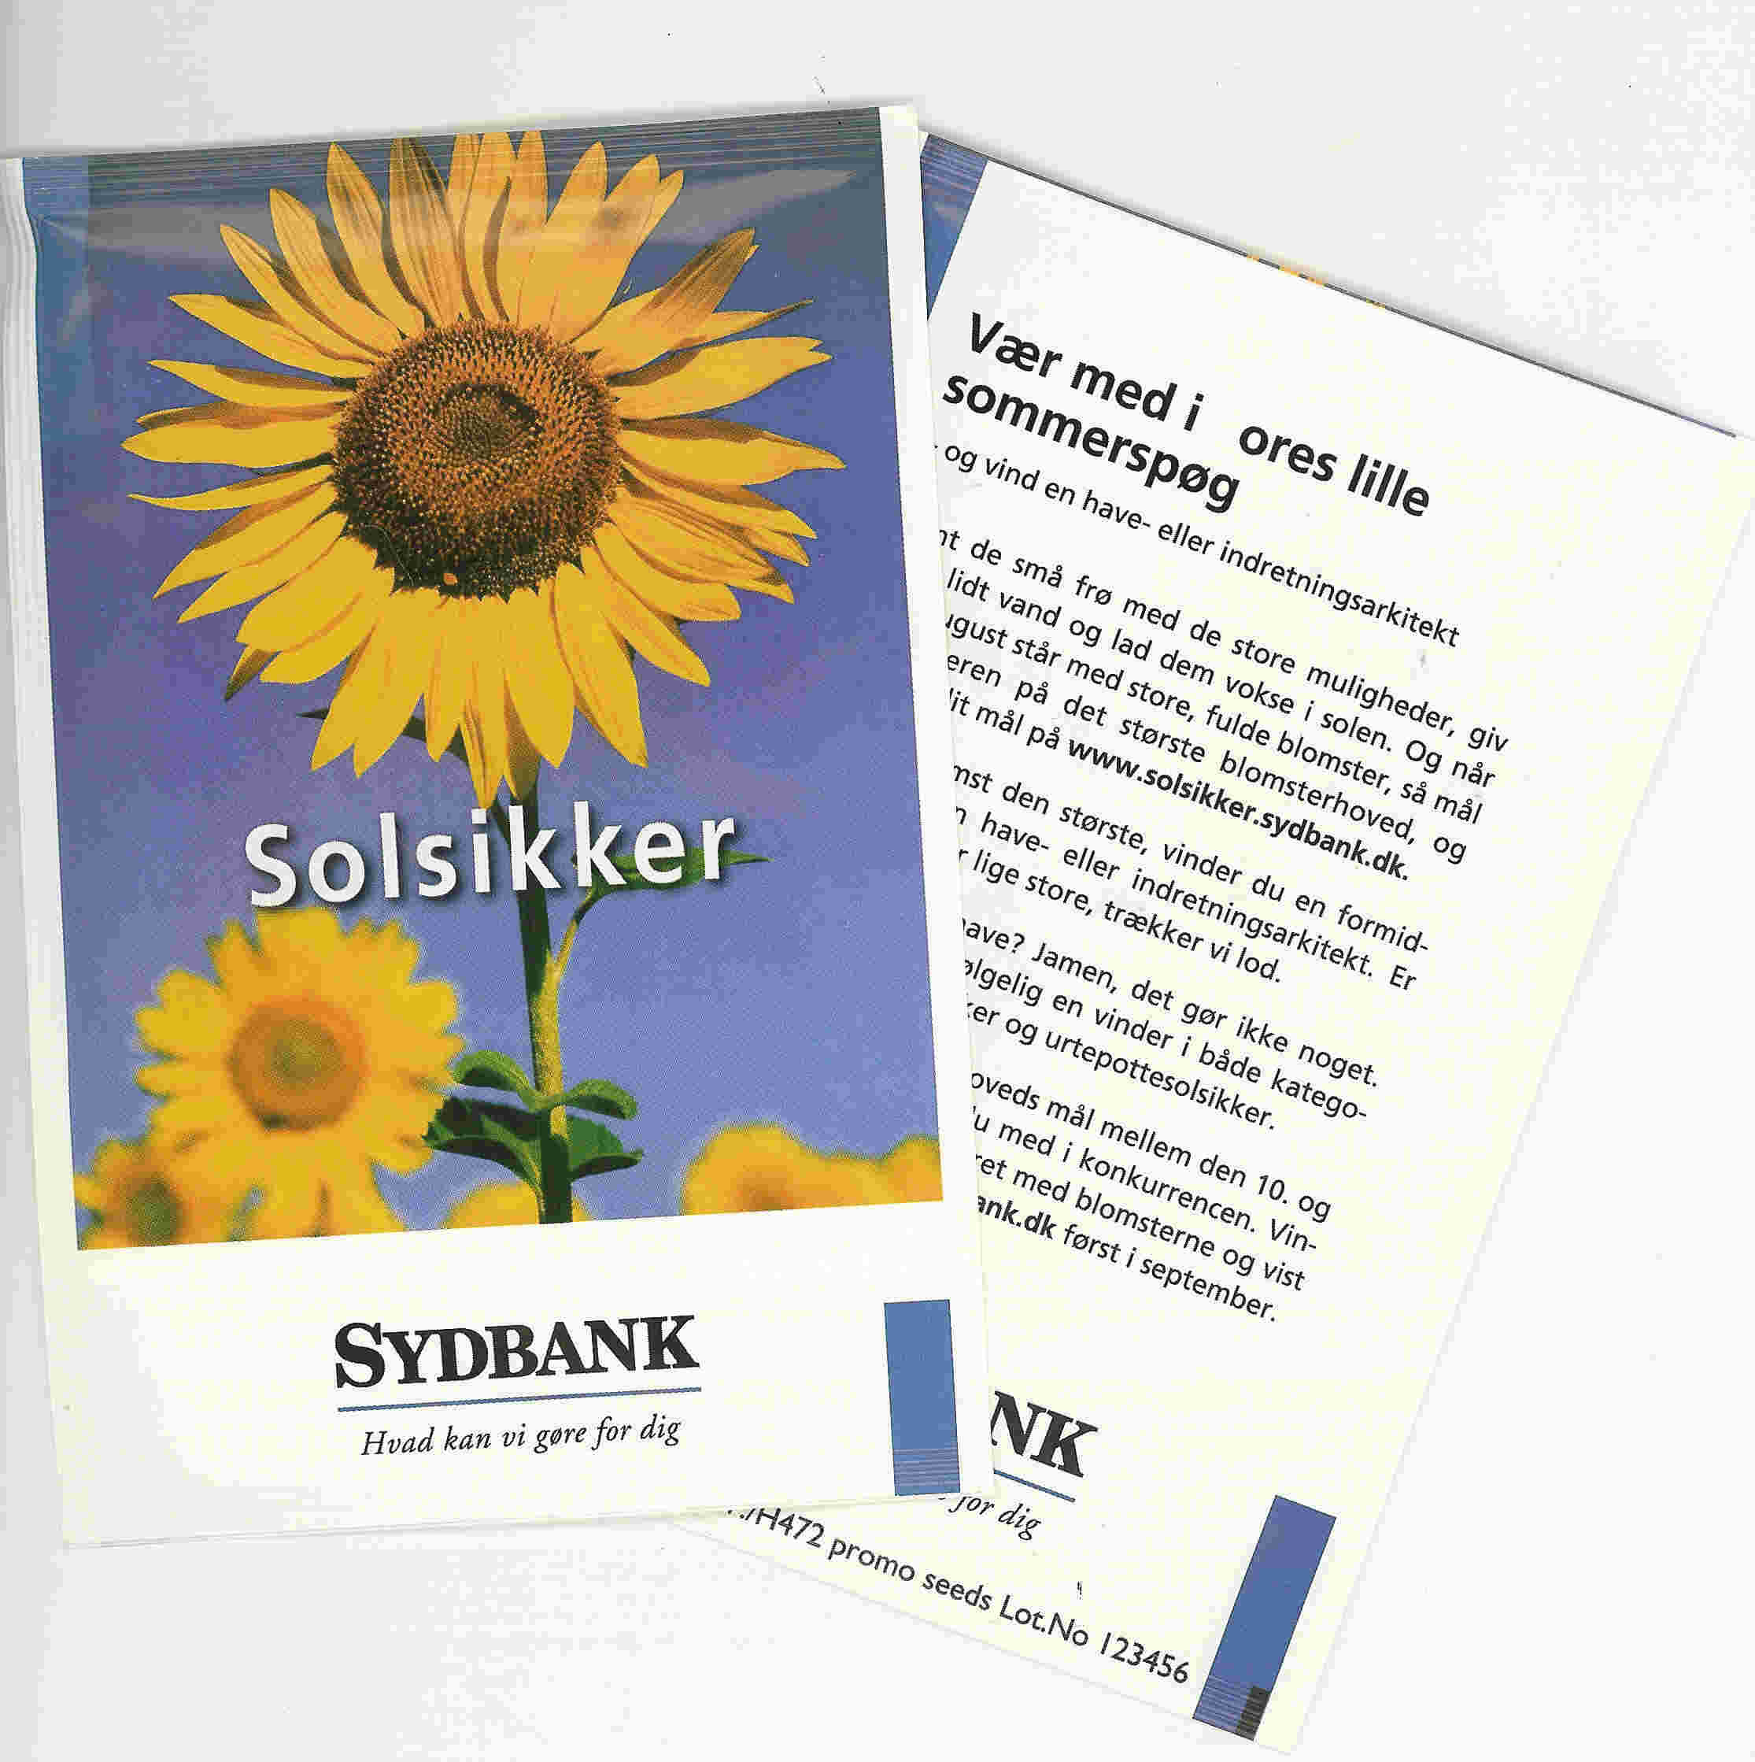
CASE 1 promo seeds scandinavia 2004

Product: Seedpack in postcardsize 102 x 150 mm
with Sunflowers
Quantity 160.000 pcs.

Customer: Sydbank – DK
One of The 4 largest bank in Denmark.
They have 115 departments (2 in Germany)
2.000 employees.
Marketvalue 6.600.000.000 DKK

Event: Competition, 1. price is an
Gardenarchitect to make a project for the winner.

Storry: The Bankcustomers has been informed in an advertisements that there was a little gift with
the Competitions-conditions on in each department of Sydbank over the country.
The seedpack-gift was with the Competitions-conditions on the backsite.
That person with the biggest Sunflower is the winner of an architect for one day.

Result: The customers and other interested persons
went to the Bank to get a free of charge seedpack.
The whole family was in activity to this project.
The result afterward was delivered as a photo of the Sunflower
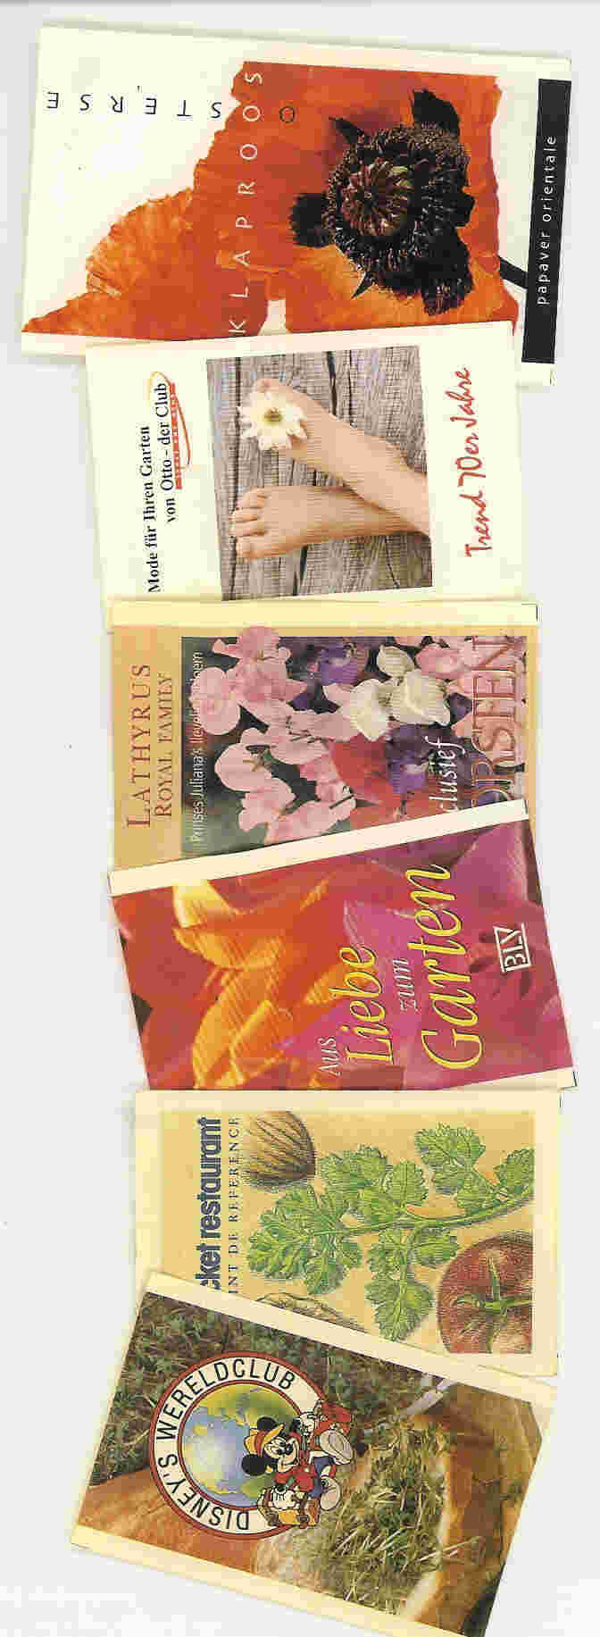
with a measure by size to the Department.
The winner was annonced on an speciel website on the internet.

Productdata: Seedpack in paper/pe. Postcard size 102 x 150 mm.
Printet in 4 + 4 colours,
The advertising agency has made the layout and printingmateriel.
Contens: Helianthus annuus giganteus.


